~
ADVERTISEMENT:
Shop lemonmama.com tokens on ebay | https://www.ebay.com/usr/morjas-0
~

#0260
2026-09-25
lemonmama.com
By author Morgan Jassen

Notes Install Roundup-Tracker

This is screenshots from installing Roundup Issue Tracker (open source Python app) in demo mode on Ubuntu.

https://www.roundup-tracker.org/

Screenshot 01, install roundup tracker demo mode here below:
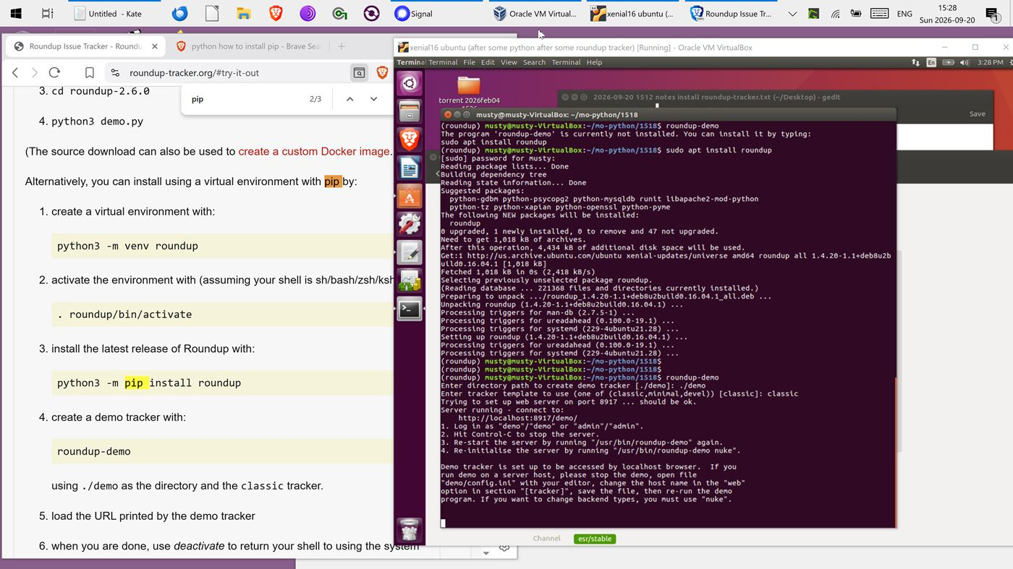

Screenshot 02, running roundup demo tracker here below:
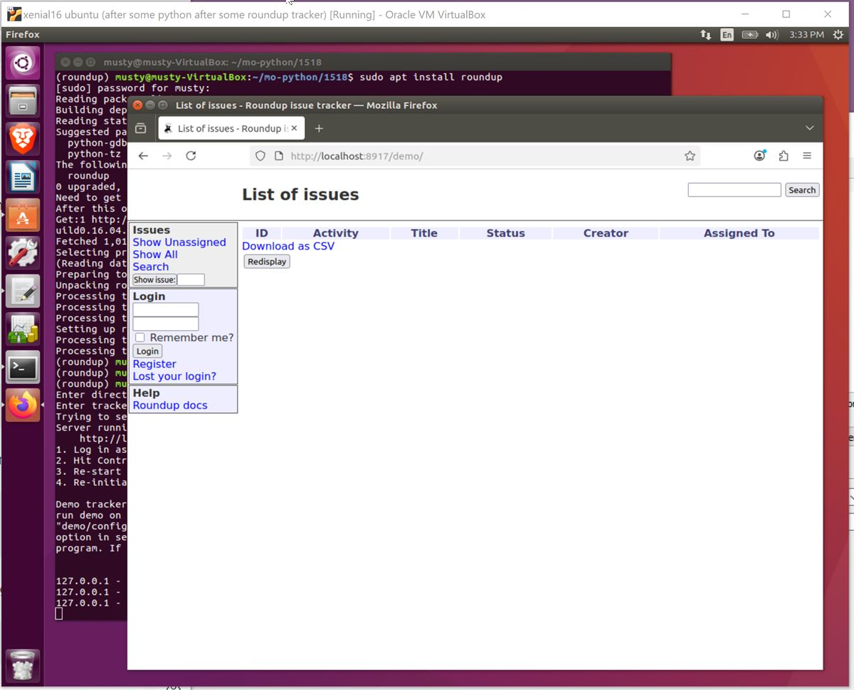

Screenshot 03, demo roundup create first issue here below:
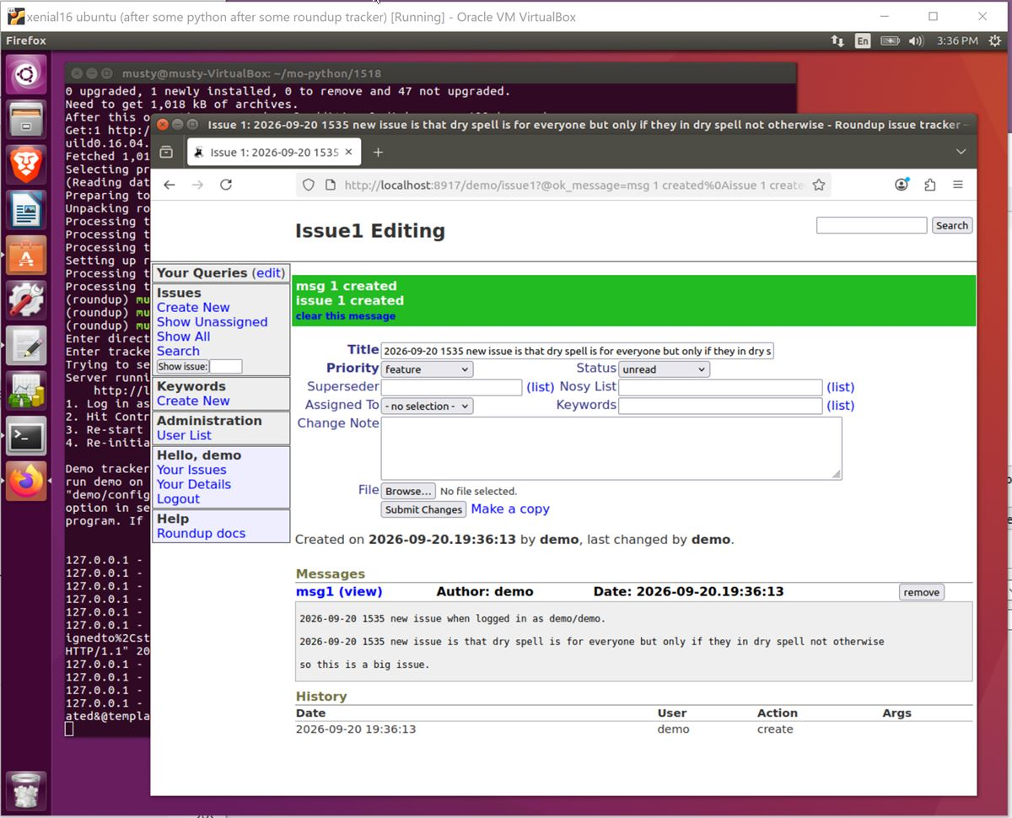

In conclusion, these were screenshots installing Roundup Issue Tracker (open source Python app) in demo mode on Ubuntu.

~

